Here Our Both Clients are registered with Eureka Server

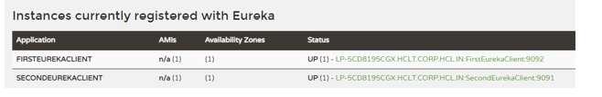

Instead of local host and port number we have used service name http://**SecondEurekaClient**/secondClient

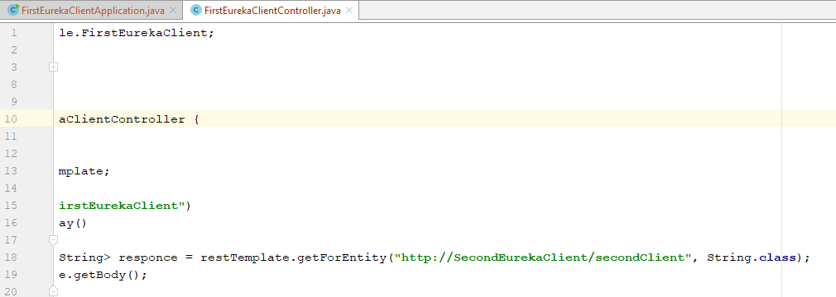

We are getting the result

